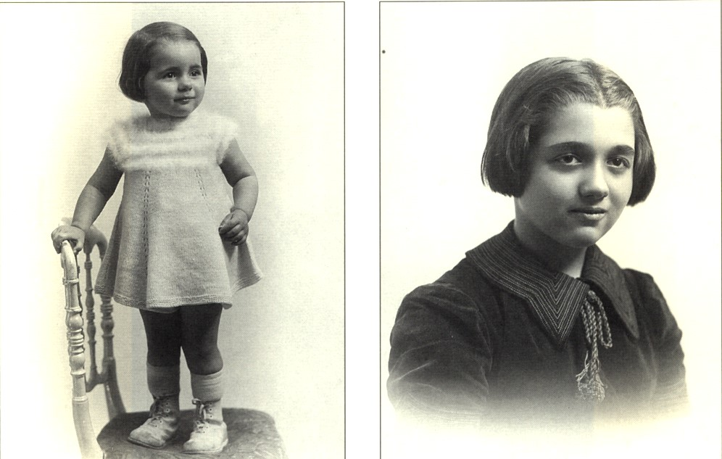
Nicole Jeanine
Jeanine NOCHIMOWSKI, born on August 7, 1926, in Paris, was deported with her parents, Rachel and Joseph, and her sister Nicole, age 7, on May 20, 1944, on convoy 74. They were arrested at Bizonnes in Isère.

FRENCH CHILDREN OF THE HOLOCAUST
A memorial
Serge Klarsfeld
 | Back | Page 1064 | Forward

